# Partnering for Kingdom Success In Baja California

**NOVEMBER 2014**

**PRAISES**

* For the new believers produced through these relationships between churches.
* For the sacrificial commitment of our Field Coordinators.

**PRAYER REQUESTS**

* For the January launch of the new church in Rosarito, Mexico.
* For the January baptisms in Merida, Mexico.
* For new gifts to bring our Field Coordinators to the Triennial in July.
* For new partnerships with NAB Churches.

________________________

NIV **2 Timothy 2:2** And the things you have heard me say in the presence of many witnesses entrust to reliable men who will also be qualified to teach others.

Our ministry in Rosarito, Baja California is a good example of multiple partnerships working together to see kingdom results. Paco Damian, HFC Field Coordinator in Central Mexico, has been working closely with Pastor Gonzalo Gonzalez to help launch a new church there and build the pastoral network in Northwest Mexico. They currently have three groups meeting each week and beginning in January will have a Sunday morning service in the Hotel “Las Brisas”.

This growing work has benefited from many relationships along the way. In the last few months, not only has Paco visited them but Gabe Meiers (Comunidad Cristiana – Gresham, OR) and Tony Campos (Casa de Luz – Sacramento, CA) have visited and their Hispanic churches are now supporting this mission field financially. A leadership team from NAB Women’s Ministry has also visited to explore the idea of supporting Gonzalo and his wife in their ministry specifically to women in Baja. Randy and Shelly Schmor were part of this team as well representing the Women’s Ministry and Gateway Teams.

These productive relationships between the mission field and local North American churches, NAB Women’s Ministry and Gateway Teams illustrates the work of HFC. Initiating and resourcing networks that result in new churches.

# Rafaela - Argentina

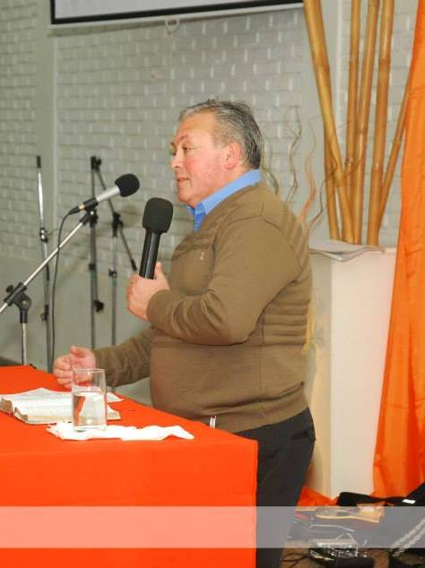David Ibarra (Field Coordinator in Central Argentina) recently shared about the past, present and future works his ministry has been involved with. They celebrated the one year anniversary of a new church started in Parana, a city of over 250,000 about 130 km to the east of Rafaela. They also have a new work in process in Tostado to the north of Rafaela 250 km. A new believer in their church in Rafaela moved to this town, began winning families to Christ and is now being trained to be their pastor. As for the future, David and his team are preparing a team to relocate to Tucuman next March to plant a new church there.

We are still looking to find an NAB church looking to partner with Iglesia Jesucristo Mi Esperanza and our Field Coordinator David to support his ministry of Christian radio, churchplanting and pastoral training. There is so much more that could be done working together.

# Baptisms in Mexico

This coming January 2015 Ricardo Ayala (Field Coordinator – Chicago) and Geoff Hartt (Director), and Calvary Baptist in Easton, PA will join Juan Tun (Field Coordinator – Yucatan) in Merida, Mexico to celebrate a combined baptism service between the church we helped start in Quintana 6-7 years ago and two new works in process in Dzidzantun and Huhi. We are expecting 15-20 believers to be baptized and then have a big fiesta afterwards!

# Triennial Gathering

In past years we were able to gather all nine of our Field Coordinators together for a few days of encouragement, training and planning. It has now been four years since they were all together. These men represent four distinct associations/networks of churches in Latin America with close to 100 evangelical churches. Among NAB churches in North America our three Field Coordinators oversee nine churches. These men sacrifice and serve tirelessly (all serve a local congregation as well as regionally.) Our dream is to bring these men together a few days before the Triennial and then have them attend. We need to raise the funds to do this. If you would like to help make this possible with a special gift please contact Geoff Hartt at [geoff.hartt@hispanicsforchrist.org](mailto:geoff.hartt@hispanicsforchrist.org) .